CSC175 Data Communications & Networking

Spring 2026 Midterm Exam (Version B Backup)
Student Name: _______________________ID:_______________________
Total Points
Note: This exam paper should be kept confidential and any dissemination violates copyright.
Q0 | Q1 | Q2 | Q3 | Q4 | Q5 | Q6 | Q7
/20 | /10 | /10 | /10 | /15 | /15 | /10 | /10

Q0 (20 points) Multiple-choice questions: enter your answer keys here:
1 | 2 | 3 | 4 | 5 | 6 | 7 | 8 | 9 | 10
11 | 12 | 13 | 14 | 15 | 16 | 17 | 18 | 19 | 20

For the following multiple-choice questions, each question has exactly one correct answer key. If multiple choices are correct, choose the option “All of the above”. Fill in the answer keys in the table above. (Answer keys written in the question area will not be counted.)
1. What distinguishes a Host from a Switch or Router?
A) Hosts forward packets; Switches generate data
B) Hosts are end machines (like laptops); Switches forward packets toward destinations
C) Hosts operate at Layer 1; Switches operate at Layer 4
D) Hosts are only for receiving; Switches are only for sending
2. Which of the following is true about Layer 3 (The IP Layer)?
A) It strictly uses only wired links
B) It connects many local networks to form a global network
C) It handles the physical voltage on the wires
D) It guarantees the order of packet arrival
3. What term is used to describe a stream of packets exchanged between two endpoints at Layer 4?
A) Flow (or Connection)
B) Circuit
C) Voltage
D) Spectrum
4. Which of the following is a characteristic of Layer 3 (Best-Effort service)?
A) Packets are guaranteed to arrive in order
B) The network notifies you if a packet is lost
C) Packets are limited in size and could get lost, reordered, or corrupted
D) The network uses encryption to protect all packets
5. How does demultiplexing at Layer 3 work?
A) By encrypting packets so only the intended recipient can read them
B) By adding a header field that tells the receiving end what the next higher-layer protocol is
C) By splitting large packets into smaller pieces
D) By routing packets along multiple paths simultaneously
6. What is a "logical port" in networking?
A) The physical cable connector on a network interface card
B) A number identifying an application, existing in software
C) A dedicated circuit established between two hosts
D) The maximum speed a link can transmit data
7. Why do well-known ports (like port 80 for HTTP) have fixed numbers?
A) To reduce the size of packets
B) To increase network security
C) So that clients can find the server without pre-arrangement
D) To limit the number of simultaneous connections
8. What is the bandwidth-delay product?
A) The total number of bits transmitted in one second
B) The capacity of the link (how many bits fit in the link at a given instant)
C) The maximum packet size that can be transmitted
D) The ratio of transmission time to propagation time
9. For an 800-bit packet on a link with bandwidth = 1 Mbps and propagation delay = 1 ms, what is the total packet delay?
A) 0.0008 ms
B) 0.8 ms
C) 1.8 ms
D) 1.0008 ms
10. What is transmission delay?
A) The time it takes for a bit to travel across the link
B) The time it takes to put all bits of a packet into the link
C) The time a packet waits in a router queue
D) The total time for a packet to reach its destination
11. When choosing between two links, which factor dominates for a small packet?
A) Bandwidth
B) Propagation delay
C) Packet size
D) Buffer capacity
12. When choosing between two links, which factor dominates for a large packet?
A) Propagation delay
B) Bandwidth (which determines transmission delay)
C) Physical distance
D) Router processing time
13. What is the 'Count-to-Infinity' problem?
A) A loop where routing updates bounce back and forth, incrementing costs indefinitely
B) When a router runs out of memory
C) When a packet takes too many hops to reach the destination
D) When the network bandwidth is infinite

14. Which technique prevents a routing loop between two immediate neighbors?
A) Poisoned Reverse
B) Infinite Bandwidth
C) Manual Configuration
D) Using IPv6
15. Does Poisoned Reverse solve all counting-to-infinity loops?
A) Yes, it solves all loops permanently
B) No, it only works for loops involving 2 nodes
C) No, it only works for loops involving 3 or more nodes
D) It creates more loops
16. What defines the 'state' of a node in Distance-Vector routing?
A) Its physical location
B) Its distance vector (costs to all destinations) and its forwarding table
C) The amount of RAM it has
D) The number of cables plugged in
17. How does route aggregation (supernetting) help reduce routing table size?
A) By deleting routes to unpopular websites
B) By combining multiple adjacent small prefixes into one larger prefix
C) By converting all IPv4 addresses to IPv6 automatically
D) By storing tables in the cloud instead of on routers
18. What is 'Multi-homing' and how does it affect aggregation?
A) Connecting to multiple ISPs for redundancy; it breaks perfect aggregation
B) Using multiple computers at home; it improves aggregation
C) Moving a laptop between work and home; it has no effect
D) Hosting multiple websites on one server; it reduces table size
19. If a packet matches two entries in a forwarding table (e.g., 4.0.0.0/8 and 4.29.0.0/16), which one is used?
A) The first one in the list
B) The one with the shortest prefix length
C) The one with the Longest Prefix Match (most specific)
D) The router randomly picks one to load balance
20. Approximately how many addresses does IPv4 provide?
A) 1 million
B) 4 billion (2^32)
C) 340 undecillion (2^128)
D) 16 million

Q1. (10 pts) Links and End-to-End Delay
A packet of size 1,000 bits is sent from Host A to Host D through three links (store-and-forward). Each link has different transmission rates and propagation speeds.
Link | Distance | Propagation Speed | Transmission Rate
A → B | 1,000 km | 1 × 10⁸ m/s | 1 Mbps
B → C | 2,000 km | 2 × 10⁸ m/s | 1 Mbps
C → D | 3,000 km | 1 × 10⁸ m/s | 2 Mbps
Compute the end-to-end delay (transmission + propagation), assuming store-and-forward switching and ignoring processing/queuing delays.
ANS:

Q2. (10 pts) Dijkstra Shortest Paths
Consider an Autonomous System with 5 routers (A, B, C, D, E) connected by bidirectional (undirected) point-to-point links. The link costs are shown in the figure. Use Dijkstra’s Algorithm to compute the shortest path tree from the Source Router A. Break ties in alphabetical order.
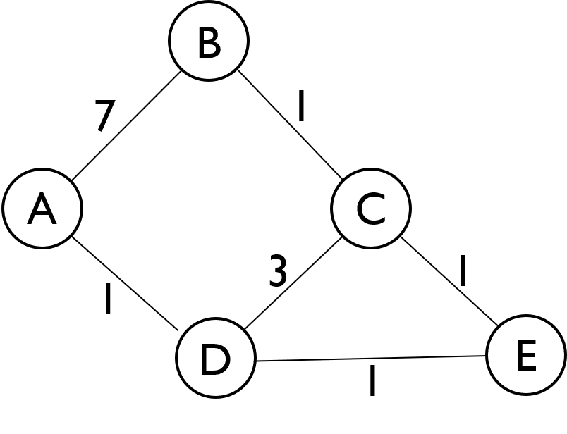
- List the Visit Order of the routers.

- Fill out the Routing Table, keeping track of the Shortest Distance (SD) and Previous Node (PN). When a shorter path is found to a router, cross out the old value and write the new one.
Node | SD | PN
A | 0
B
C
D
E

Q3. (10 pts) Distance-Vector Steady State and Failure
Alice (𝐴), Bob (𝐵), Connie (𝐶), and Diego (𝐷) are connected to the local network, which runs the distance-vector algorithm.
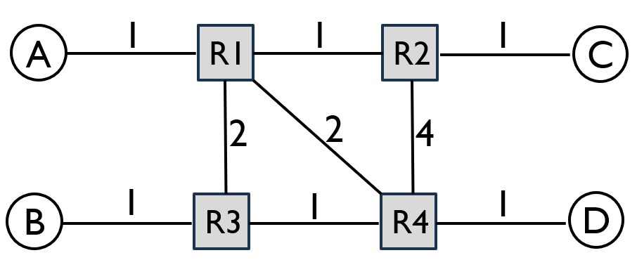
a) Fill in R1’s table at steady state. If a host is directly connected, the next hop is “Direct”.
To | Next-hop Router | Cost
A | Direct | 1
B
C
D
b) After the network converges, the R1 - R2 link is broken. Fill in R1’s table at the new steady state.
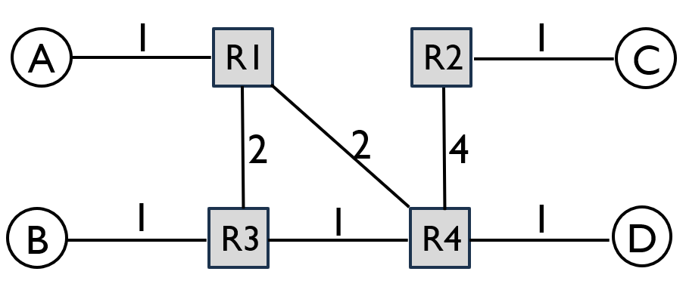
To | Next-hop Router | Cost
A | Direct | 1
B
C
D
c) After the network converges, the R1 – R4 link is broken. Fill in R1’s table at the new steady state.
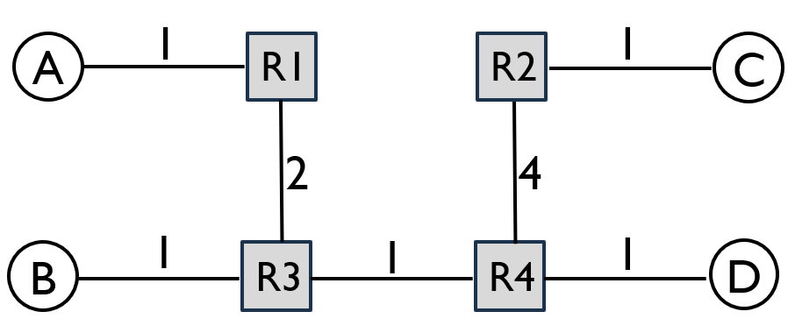
To | Next-hop Router | Cost
A | Direct | 1
B
C
D

Q4. (15 pts) Link-State
Consider the following network graph with three hosts (A, B, C) and six routers (R1 - R6). For the following questions, assume that the routers run a link-state routing protocol and the routing state has converged. Every link is up unless otherwise noted. When picking between equal-cost paths, the routers pick the route through the neighbor with the lower ID number. For each answer, please provide a concise explanation. Note that all subparts are independent questions (changes made in one subpart do not affect the subsequent ones).
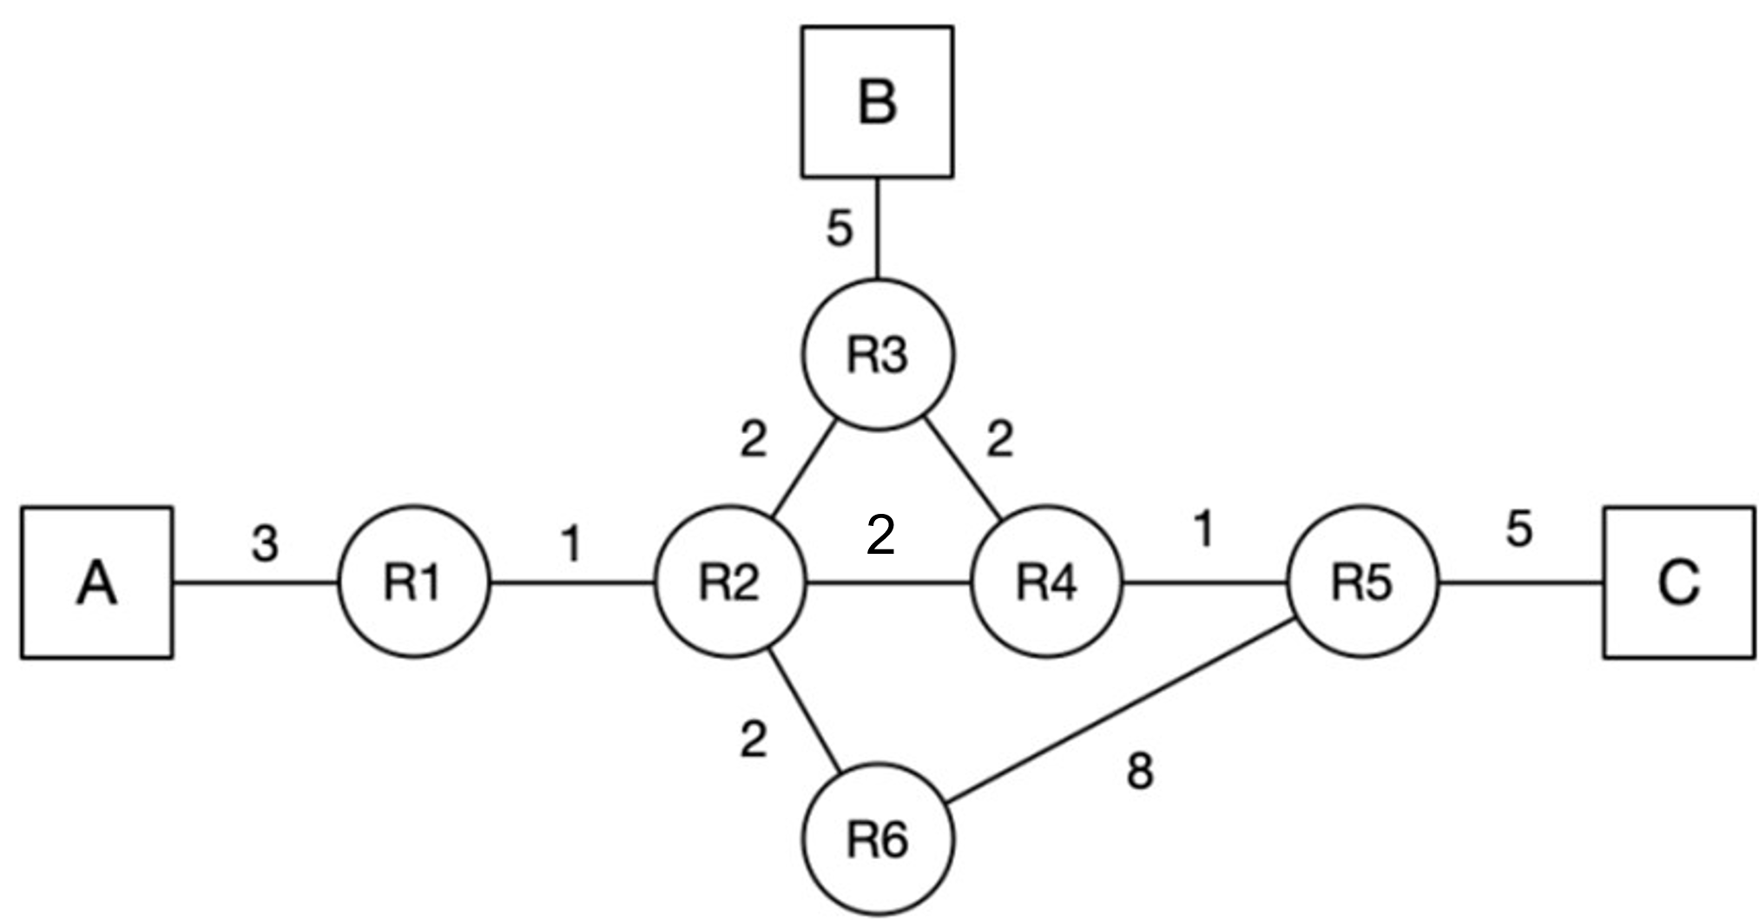
a) (2 pts) Suppose that the link between R2 and R4 goes down. R2 and R4 have recomputed their routes, but have not yet sent updates. What route will a packet from A to C take?
b) (3 pts) Suppose that the link between R4 and R5 goes down. R4 and R5 have recomputed their routes, but have not yet sent updates. What route will a packet from A to C take?
c) (10 pts) Assume that A sends a packet to C, and at time t = 0, it arrives at R1. At t = 1.5 seconds, the link between R4 and R5 goes down, and R4 and R5 instantaneously recognize and recompute their routes. Assume that link-state advertisements are processed and propagated instantaneously. A link’s propagation delay is equal to the link costs in the diagram (in seconds). You can ignore all processing and queuing delays. Does the packet reach its destination? If so, write down the route the packet from A to C takes, and fill in the table for the timing of each event, including both packet arrivals and LSA arrivals at each router or host.
t (s) | Event
0 | Packet arrives at R1

Q5. (15 pts) Longest Prefix Match
A router has 4 ports, with routing table shown below. Use these rules in order: longest prefix match, then lowest cost, then smallest port number. If no prefix matches, use the default route on port 4. Given the routing table below, for each destination IP address, determine the output port to forward it, and the routing table entry used to make that routing decision. Give a brief explanation for each item.
Port | Destination | Cost
1 | 20.0.0.0/8 | 8
1 | 180.16.0.0/12 | 11
1 | 200.10.128.0/17 | 10
2 | 20.5.0.0/16 | 6
2 | 200.10.0.0/16 | 9
3 | 180.16.32.0/19 | 5
3 | 200.10.192.0/18 | 7
4 | 20.5.7.0/24 | 6
4 | 200.10.128.0/17 | 8
Some useful binary conversions in the table below.
Decimal | Binary
192 | 11000000
128 | 10000000
96 | 01100000
208 | 11010000
50 | 00110010
32 | 00100000

Destination IP | Output port | Matched routing table entry and brief explanation
(a) 20.5.7.42
(b) 20.6.1.1
(c) 180.16.50.7
(d) 180.31.2.4
(e) 200.10.220.5

Q6. (10 pts) Route Aggregation
Consider a router running longest prefix matching to forward packets. Given the current routing table, use route aggregation to build a new table with the minimum number of entries, such that both tables produce the same forwarding decisions. Write one IP prefix per box. You may not fill all rows, or you may need to add additional rows, in the merged routing table.
- (3) Current routing table:
Destination | Port
10.0.16.0/24 | 2
10.0.17.0/24 | 2
10.0.18.0/24 | 2
10.0.19.0/24 | 2
Merged routing table:
Destination | Port
Explanation:

- (3) Current routing table:
Destination | Port
10.0.16.0/24 | 2
10.0.17.0/24 | 2
10.0.18.0/24 | 3
10.0.19.0/24 | 2
Merged routing table:
Destination | Port
Explanation:

- (4) Current routing table:
Destination | Port
10.0.16.0/24 | 1
10.0.17.0/24 | 1
10.0.18.0/24 | 2
10.0.19.0/24 | 2
10.0.20.0/24 | 1
10.0.21.0/24 | 1
10.0.22.0/24 | 1
10.0.23.0/24 | 1
Merged routing table
Destination | Port
Explanation:

Q7. (10 pts) Inter-Domain Routing under Gao-Rexford
Consider the AS graph below, where each AS follows the Gao-Rexford import and export policies. Provider to Customer relationship is denoted by arrows; peer to peer relationship is denoted by horizontal lines with dots. For each source/destination pair, select whether it is possible for packets to be sent from the source AS to the destination AS. Does the AS graph have full reachability from every AS to every other AS? If not, fill out the following table of reachability. (Hint: Every intermediate AS on a legal path must have at least one customer neighbor along that path.)
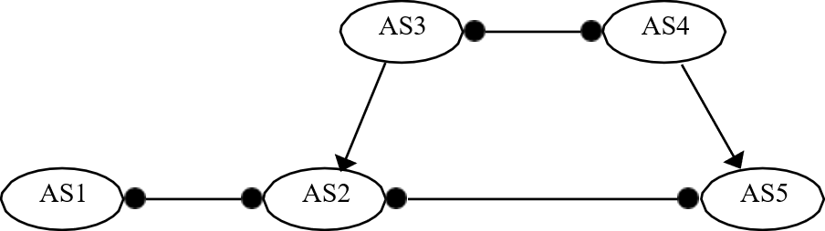
Source AS | Reachable Destinations
AS1
AS2
AS3
AS4
AS5

